Lab was completed at home.

- File is attached with the submission
- Workstations Screenshot (IPv4) 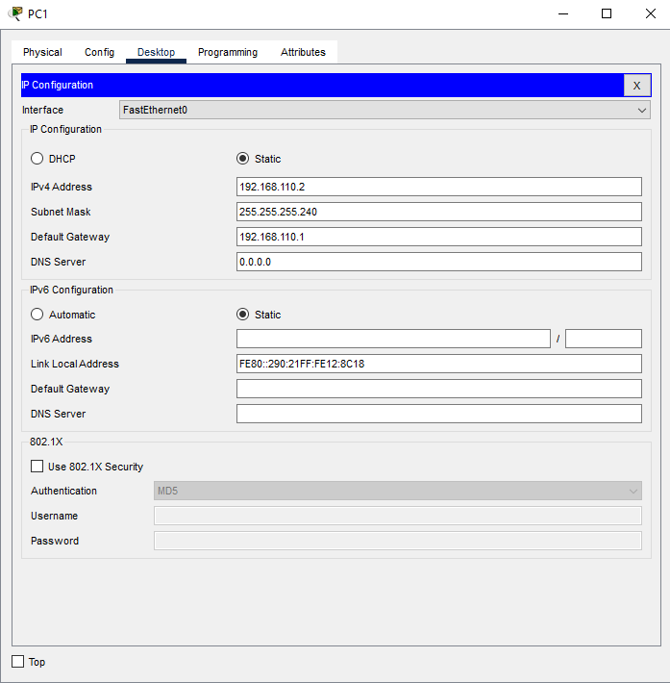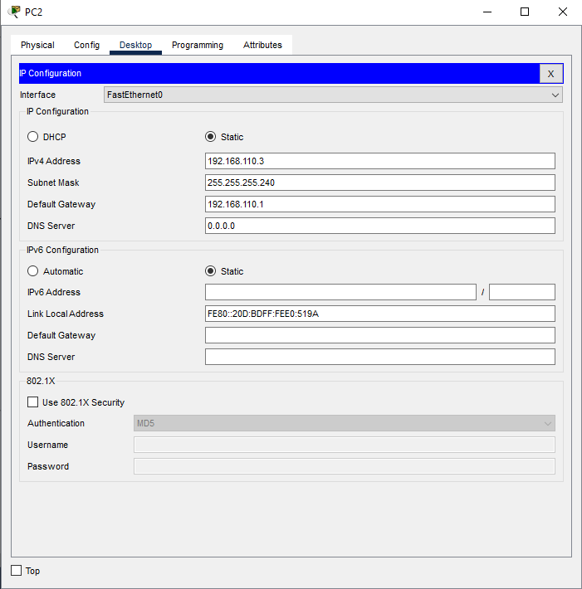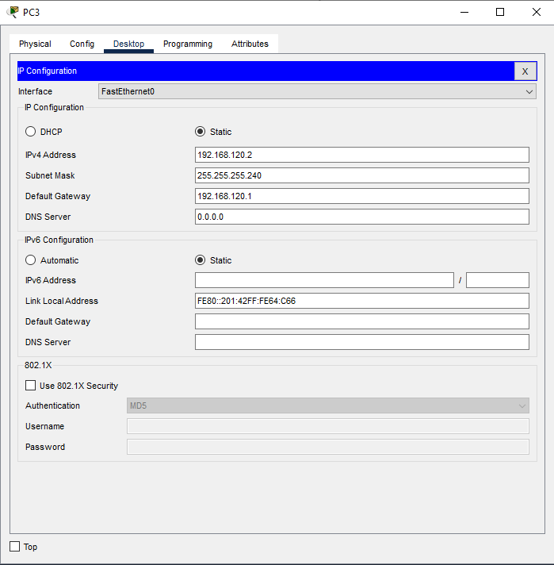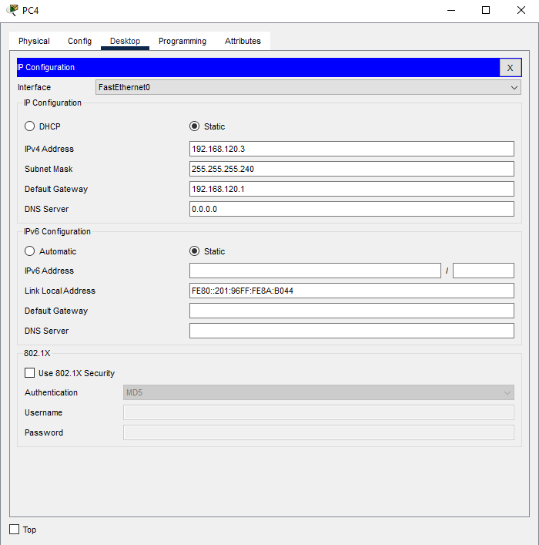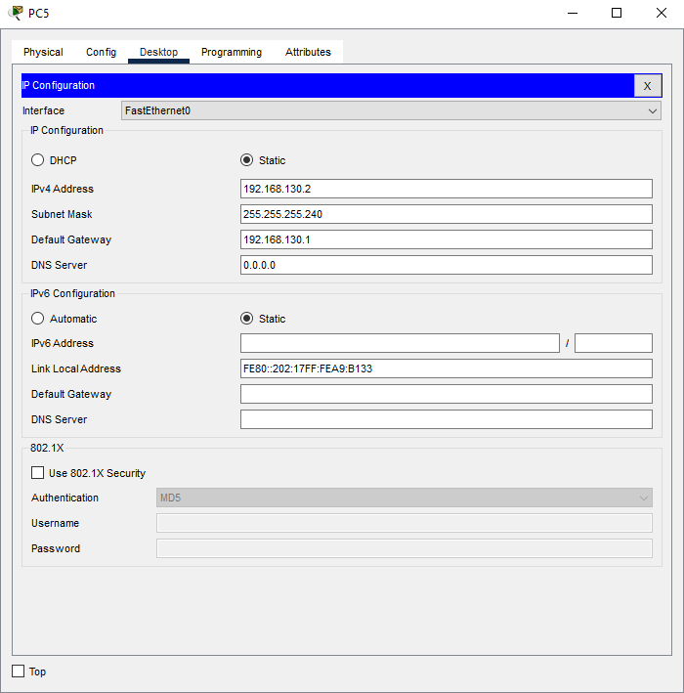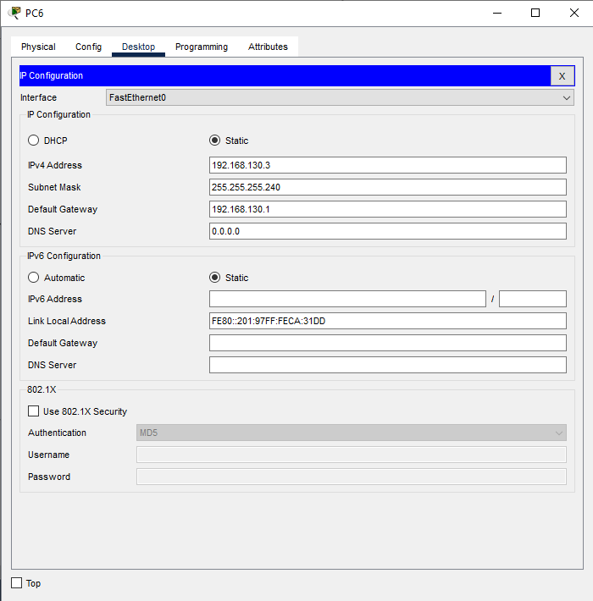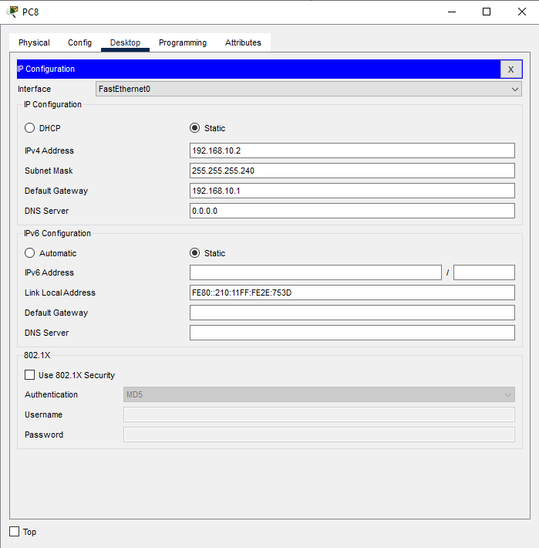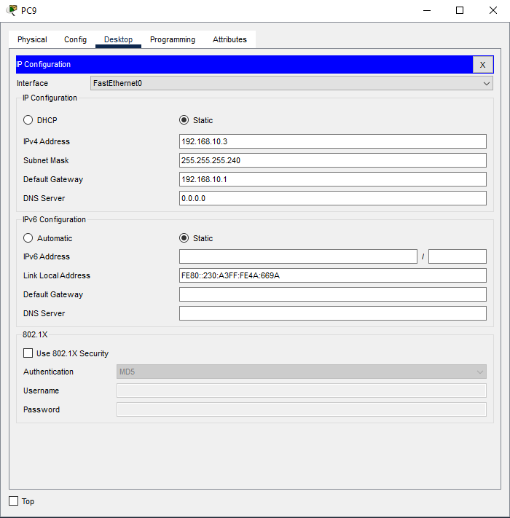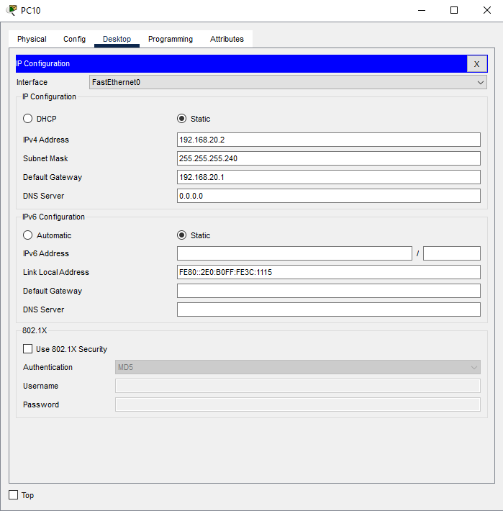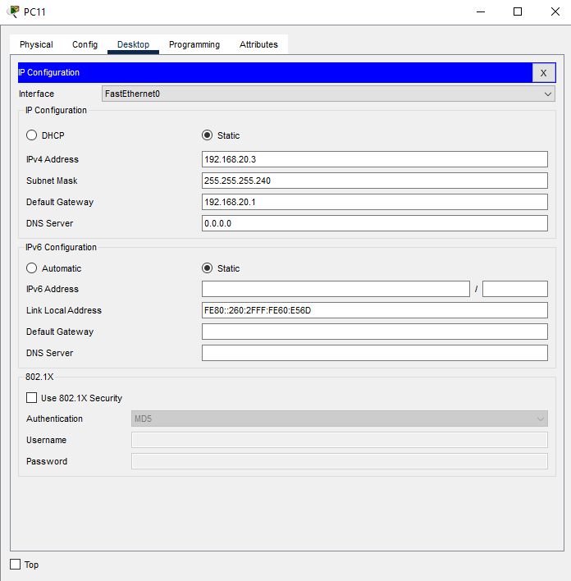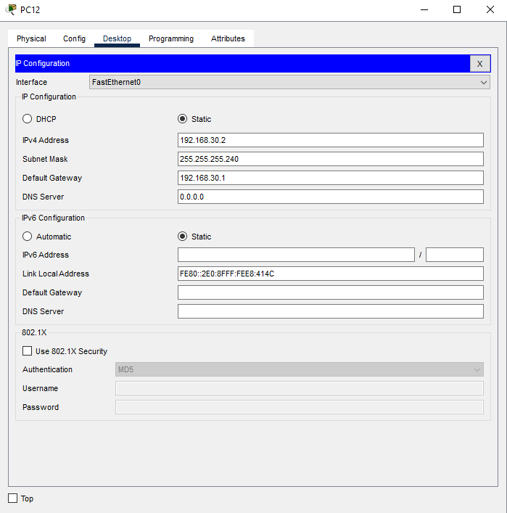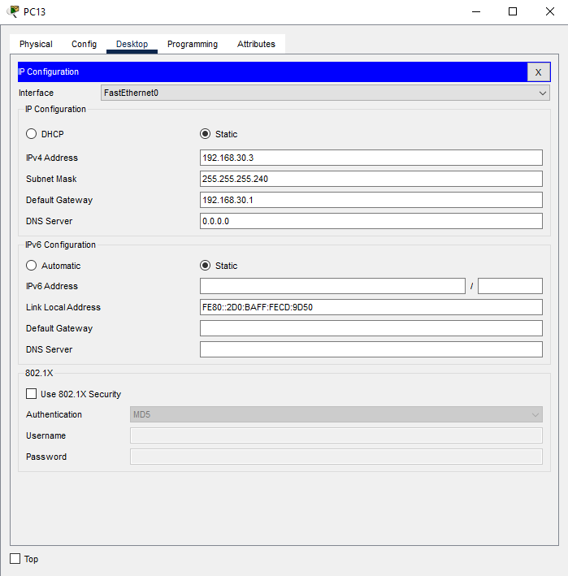

- Switch A and B Screenshots
  - #show vlan
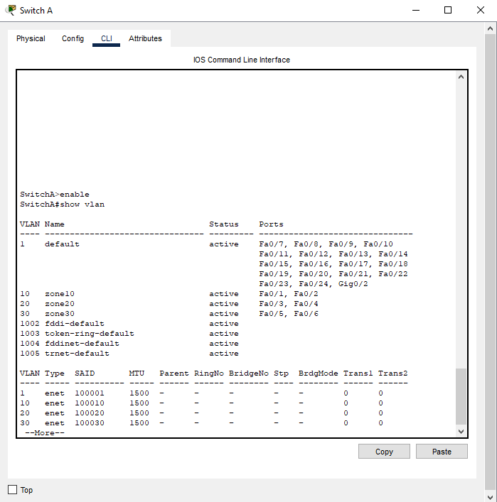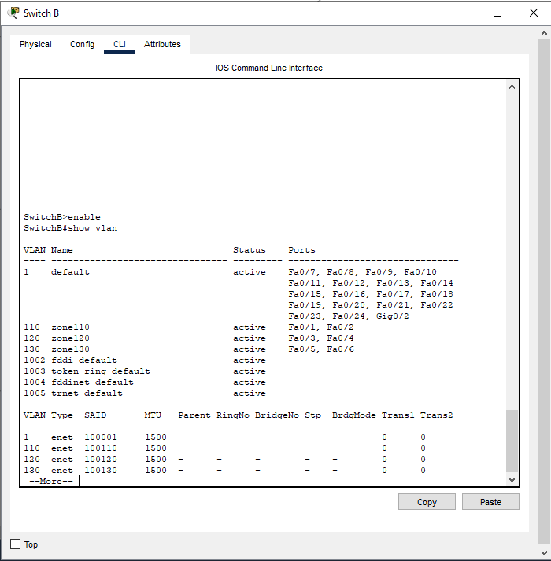

  - #show ip interface
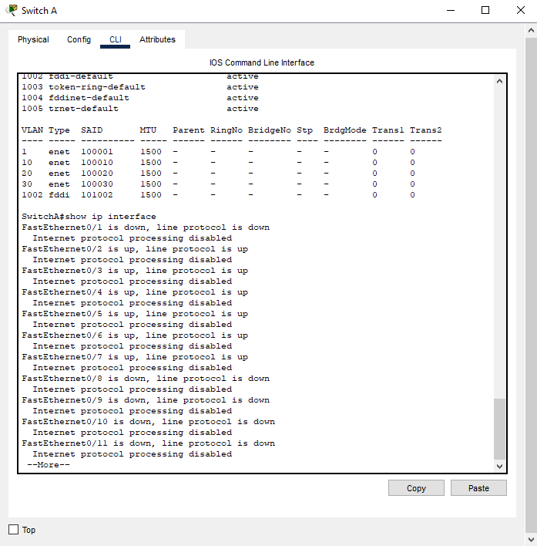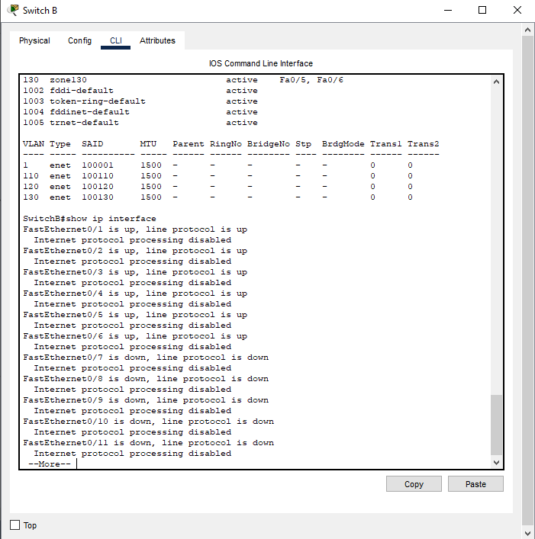

  - Switch with Cables connected
Completed Virtually at Home

- Router A and B Screenshots
  - Router 1 and 2: Running Configuration

    - #show run
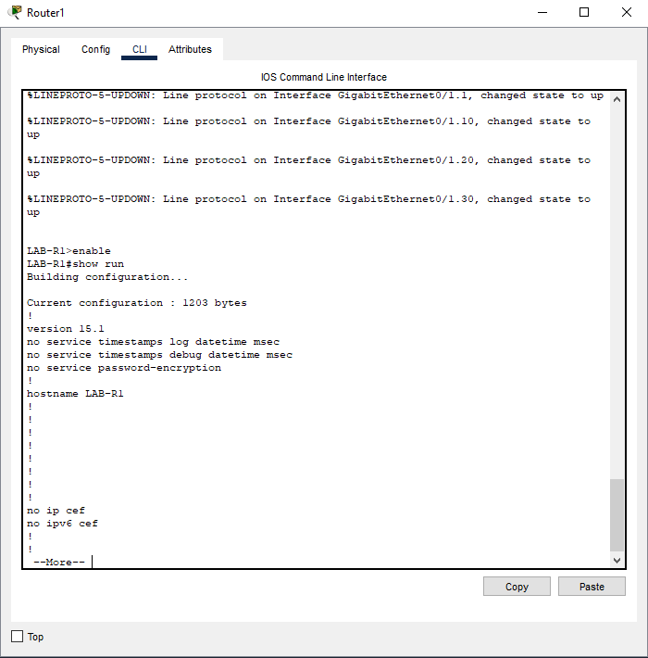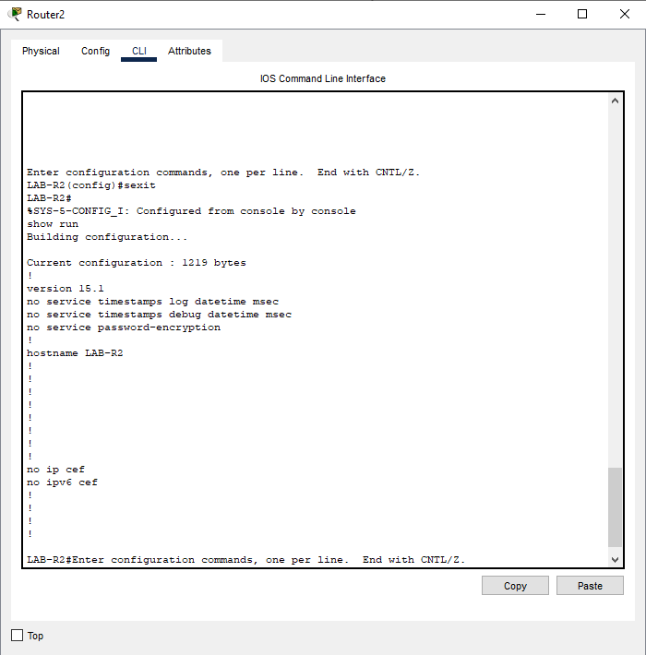

    - #show ip int brief
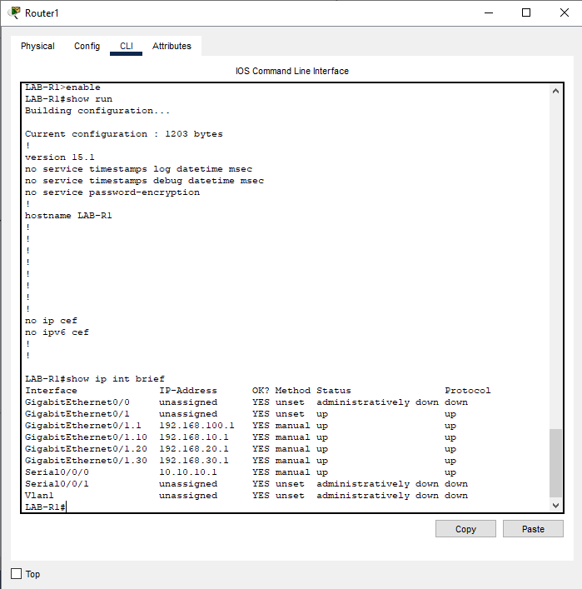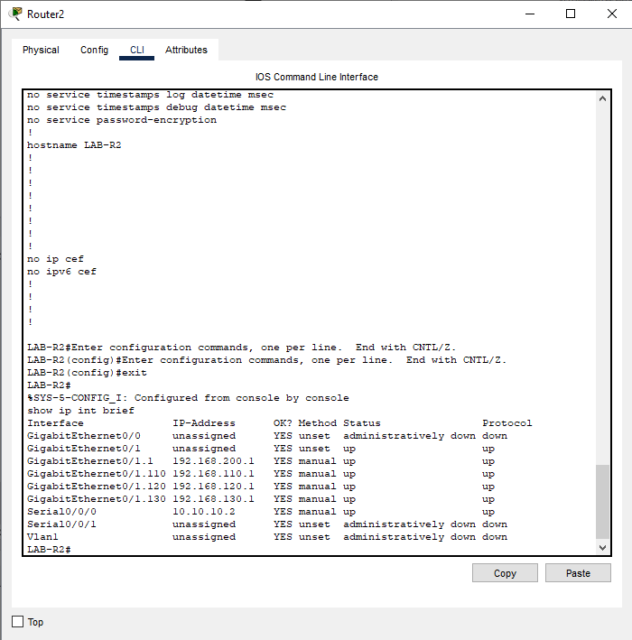

    - #show ip route
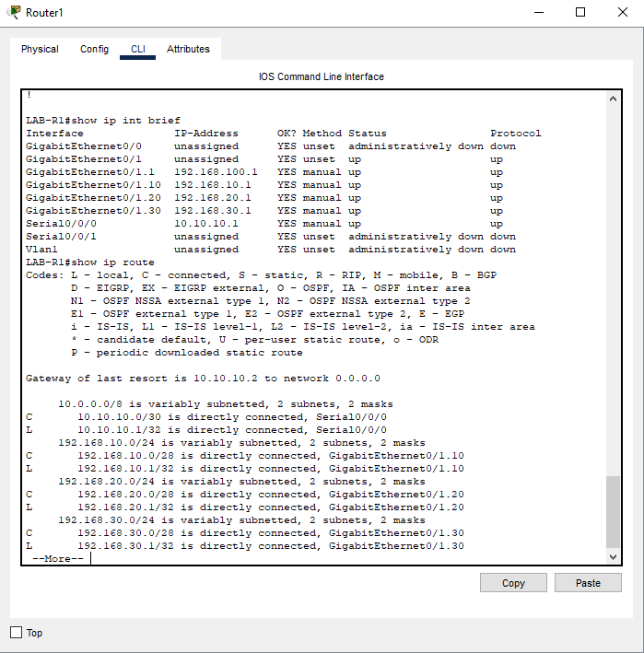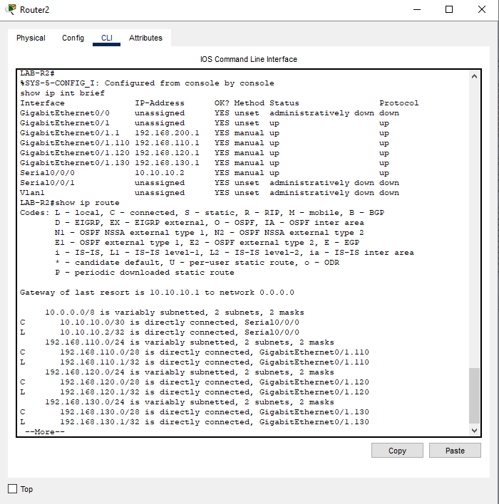
Lab Questions
1. What does TCP/IP stand for?
Transmission Control Protocol / Internet Protocol
2. What does UDP stand for?
User Datagram Protocol
3. How does TCP differ from UDP?
TCP: connection oriented, provide error checking, sequencing and reliability, and slower but ensures all data arrives in order.
UDP: connectionless and faster, no error checking or ordering, used for real-time or streaming data.
- How are these protocols similar?
Both protocols operate at the transport layer of the TCP/IP model and are responsible for moving data between applications across the network.
- List some characteristics of both:
Feature | TCP | UDP |
Connection | Connection-oriented | Connectionless |
Reliability | Guaranteed delivery | No delivery guarantee |
Speed | Slower | Faster |
Use Cases | File transfer, email | Streaming, gaming |
Header Size | | Larger | Smaller |

4. Explain the use of 0.0.0.0 in setting the static routes in this assignment.
In this lab, the use of 0.0.0.0 is used to define the default route, or the gateway of last resort. This tells the router to send any packets destined for an unknown network to a specific next-hop address, or in this case, the serial interface that connects both networks. This allows for all external or non-local traffic to be forwarded properly between the two routers.
5. What does the statement “Gateway of last resort is not set” mean?
This message means that the router doesn’t currently have a default route configured.
- Why would this matter when sending packets outside of a network?
Without a gateway of last resort, the router has no instructions for handling packets that do not match any existing route in this network. As a result, these packets would be dropped, preventing communication with devices that are on other networks.

